**Documentation**

**Elanco CRDB smoke Test Automation Suite**

**Important Notice:** This document and any attachments submitted with it are confidential and intended solely for the use of the individual or entity to which it is addressed. If you are not the intended recipient, you are hereby notified that any use, dissemination, forwarding, printing, copying or other use of this document, any attached documents, and the information these documents contain, is strictly prohibited. If you have received this by mistake, please advise the sender immediately and destroy / invalidate the document.

**Prepared for**



**Submitted By**



**WinWire Technologies Inc.**

**2350 Mission College Blvd.**

**Suite 925, Mission City Center**

**Santa Clara, CA, 95054**

[**Info@WinWire.com**](mailto:Info@WinWire.com)

**Document Information**

|  |  |
| --- | --- |
| Document Title | Documentation for smoke Test Automation Suite |
| **File Name** | Elanco CRDB Automation Suite.docx |
| **Author(s)** | Sujith Reddy |
| **Team** | WinWire Delivery Team |

**Document Revision History**

|  |  |  |  |
| --- | --- | --- | --- |
| Version | Date | Changed By | Items Changed Since Previous Version |
| 1.0 | 08/28/2020 | Sujith | Draft Version |
|  |  |  |  |

**Table of Contents**

1. Document Overview 4

2. Project Solution 4

3. Smoke test - Regression Suite 4

4. Prerequisites 5

5. Steps to Execute Smoke Test Automation Testcase 5

6. Initiating Test execution 6

# Document Overview

Elanco CRDB Automation suite covers quick intro into the automation suite, basic test setup and test execution. Also, it covers the smoke test cases outlined under Annexure.

# Project Solution

The Project is Uploaded in to Share point portal and user can access it through the below link <https://winwireinc.sharepoint.com/sites/ElancoCRDBTeam/Shared%20Documents/Forms/AllItems.aspx?viewid=9485a6c9%2D6dee%2D4c63%2D81ad%2D93b9f3382e4b&id=%2Fsites%2FElancoCRDBTeam%2FShared%20Documents%2F4%2DQADocuments%2FAutomation%20Builds>

# Smoke test - Regression Suite

|  |
| --- |
| WW has identified and outlined 6 test cases as part of smoke test |

|  |  |
| --- | --- |
| **Sl.No** | **Title** |
| SmokeTestcase1 | Reference Templates Screen as Template Author and Notifications |
| SmokeTestcase2 | Customize Country Template Screen as Affiliate Editor and Notifications |
| SmokeTestcase3 | View single country Requirements as Viewer and Export to CSV |
| SmokeTestcase4 | View multi country Requirements as a Viewer and Export to CSV |
| SmokeTestcase5 | Admin screen Navigation as Super Admin |
| SmokeTestcase6 | Delete section of Test Data in Reference Template Page as Template Author |

# Prerequisites

1.Please make sure Test data sheet is updated properly.

2.Product Type / Section / Country is always visible before running the suit.

3.Make sure Product Type / Section / Country is added in the Admin screen.

4. Make sure All Dropdowns are available.

5.Make sure Roles are properly Aligned.

6.please set the Microsoft web driver path to work on Edge browser.

7.All browsers and Drivers must be updated.

8.Test data Must be set properly in Application before running the suit.

# Steps to Execute Smoke Test Automation Testcase

* 1. **Access Test Steps Sheet:** Go to Test Data Folder > Click on CO_TestData.xlsx
  2. Go to Test steps Sheet in Test data excel and Update Run=Y if Run=N the step will be skipped
  3. **Prerequisites:**
* Make sure Product Type, section, country is = Y before running the Testsuit
  1. Can invoke the Browser instance by Updating Test Run=Y/N

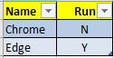

* 1. Code it written and Handled in Such a way that we can execute test in specific environment

**DEV/QA/UAT**

**Note:** In future User can add any number of environments as per the need

|  |  |  |
| --- | --- | --- |
| **Name** | **Value** | **Description** |
| ProjectName | Elanco : CRDB |  |
| UserRequested | Smoke Testing |  |
| Environment | Elanco CRDB - QA |  |
| Release | Current Sprint |  |
| System Run | **QA** |  |
| ChromeWaitPercentage | 100 | % with respect to wait given in the data file which corresponds to IE browser. Ex: 10000 ms given in data will make IE browser wait for 10sec whereas for chrome it will be 25% of it i.e., 2500ms or 2.5sec |
| EdgeWaitPercentage | 90 | % with respect to wait given in the data file which corresponds to IE browser. Ex: 10000 ms given in data will make IE browser wait for 10sec whereas for chrome it will be 25% of it i.e., 2500ms or 2.5sec |

# Initiating Test execution

1. First and fore most Save Test data sheet as Testdata.xlsx and then as XML version

Testdata.xml

Note this is mandatory step and we might end up corrupting the data.

1. Now Navigate to Visual studio and navigate to CRDB > Build solution (Ctrl+Shift+B)

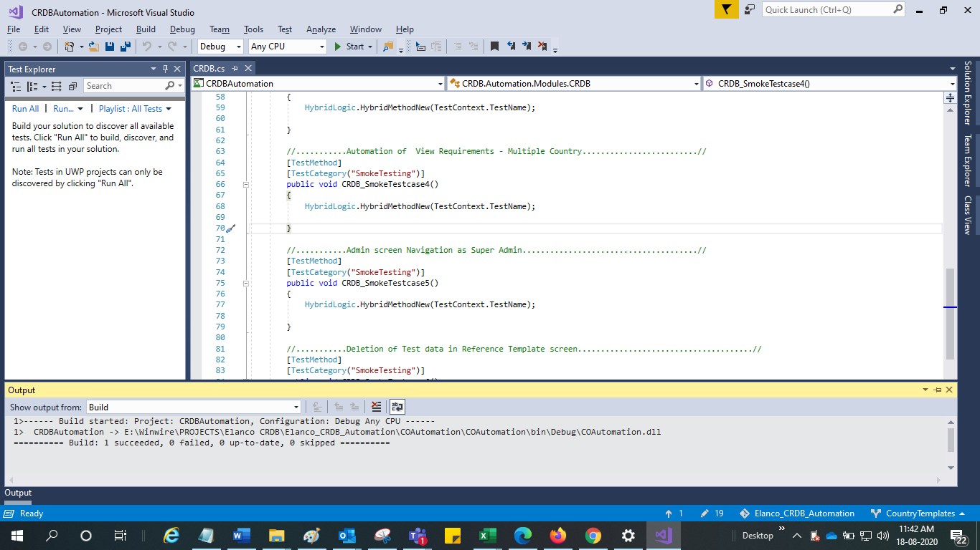

1. Run – Click on Run All and the perform RUN

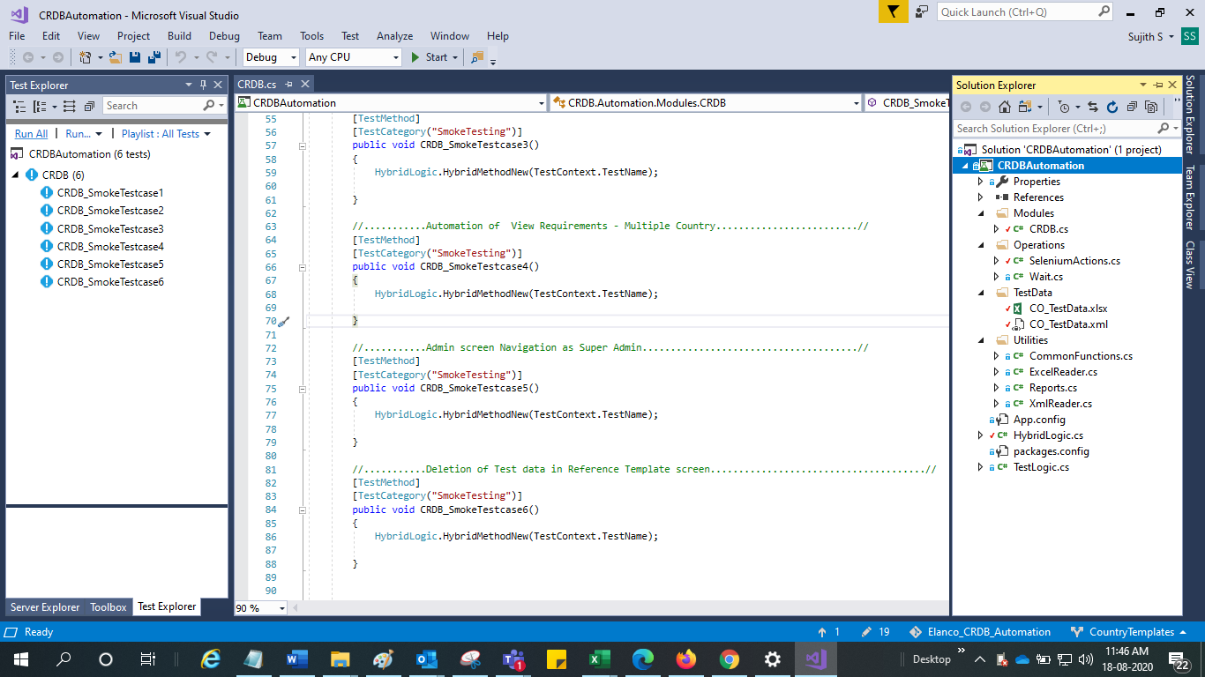

4.Now the Test will Run successfully and execute the test steps which are marked as Y in the test data sheet

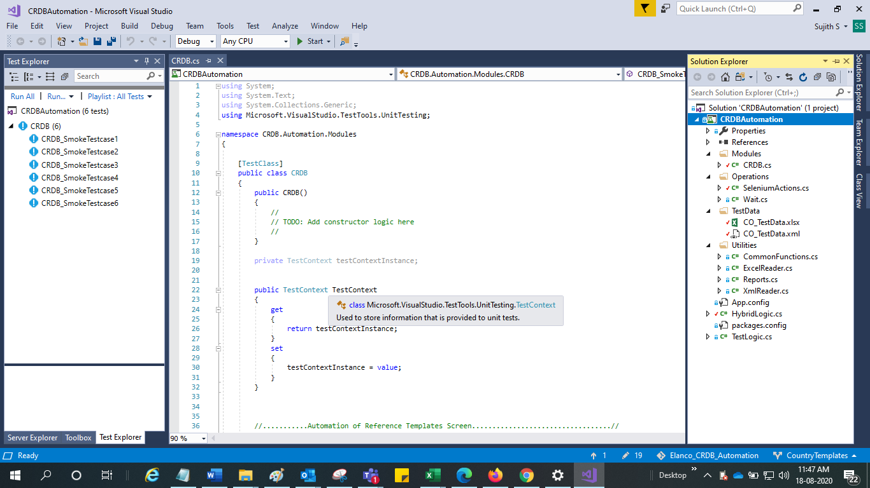

**IMPORTANT NOTE:**

Do not perform any actions like click, mouse move, Refresh the page…etc. On the screen where these test cases being executed else report will not be generated.

1. To see the Generated Report – Go to bin folder > Test Report >

Now we can see the Report Generated for each Run > click on It,

If Test is Failed, Screenshot will be captured for the specific step which was failed and stored in Screenshots folder. A hyperlink will be enabled, and screenshot will be opened when user clicks on it.

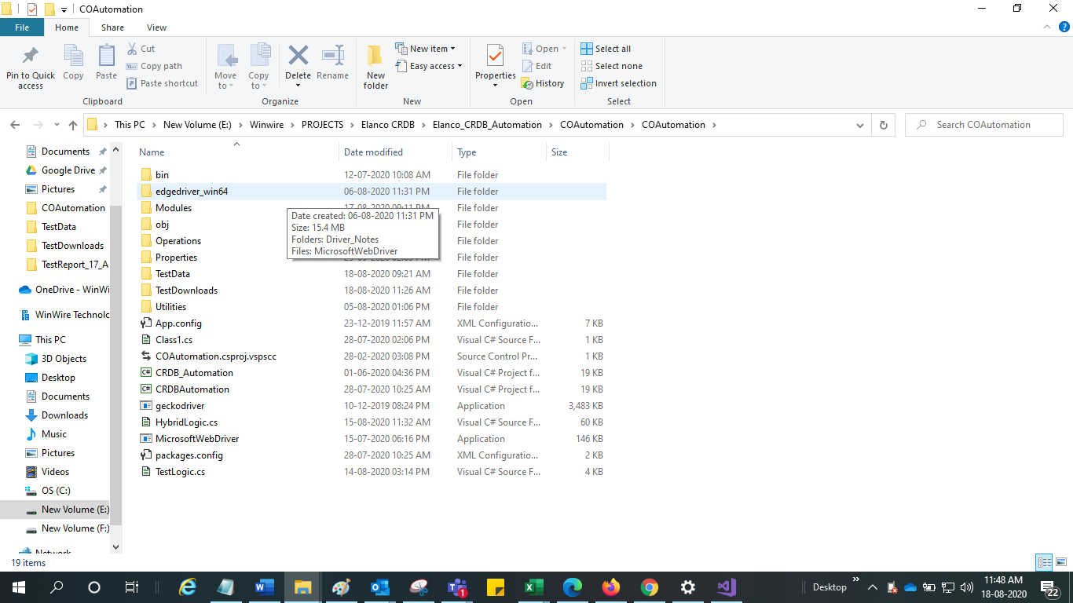

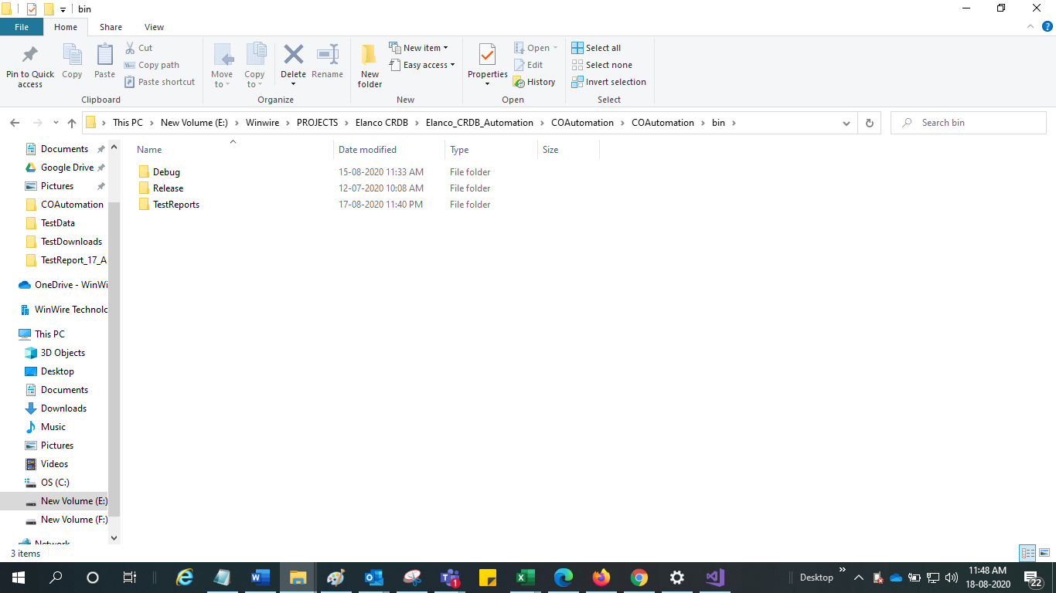

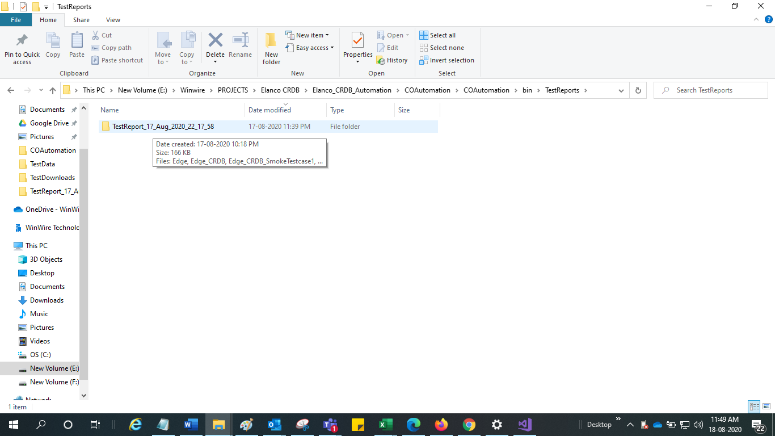

Test Report

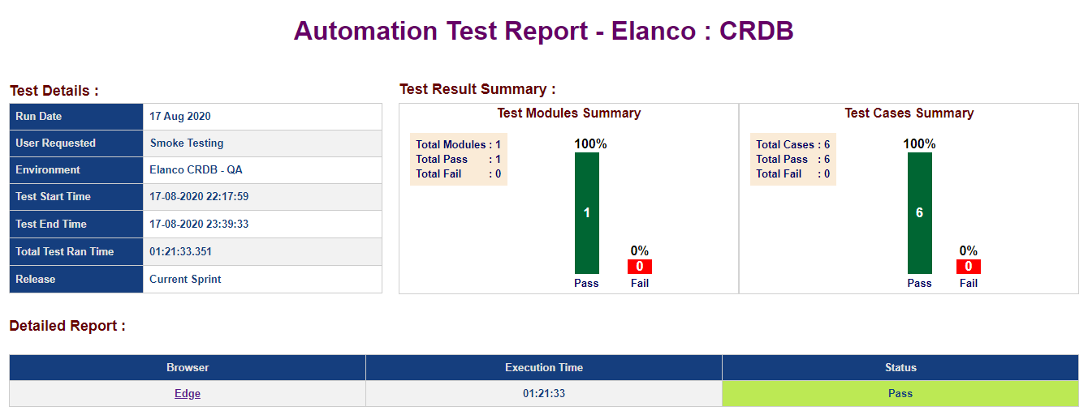

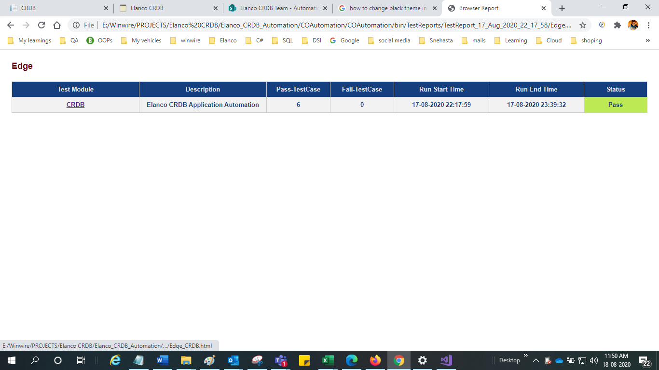

Test cases included in Test suit

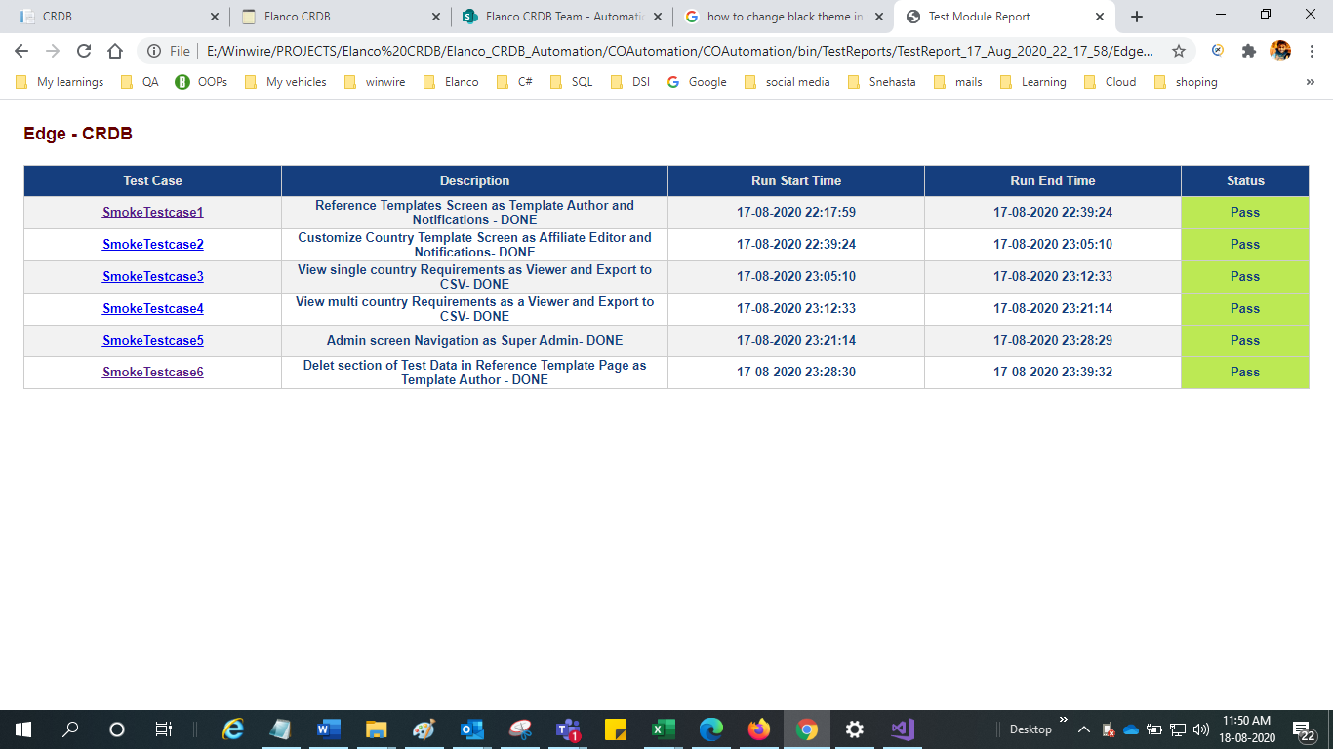

Detailed steps of each Testcase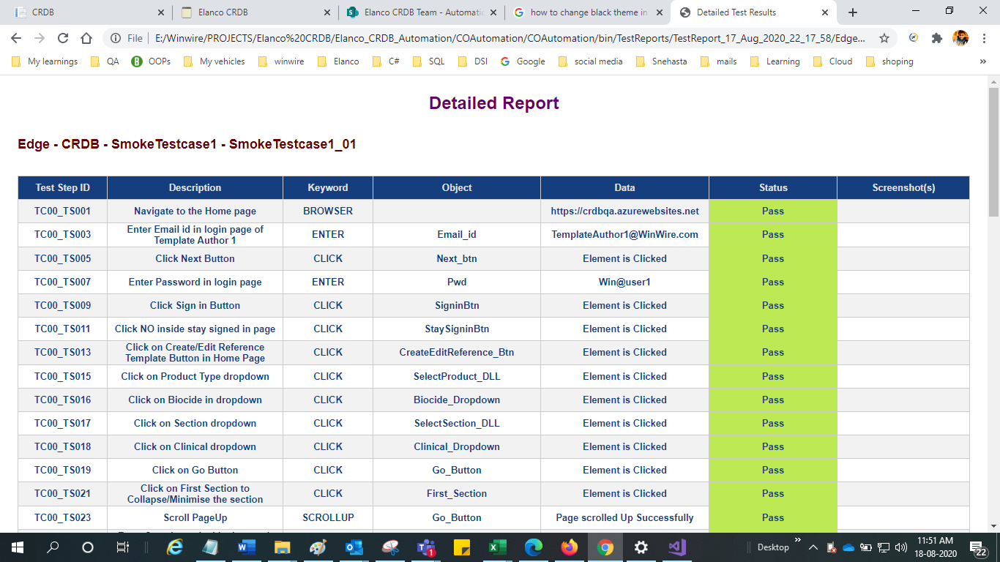

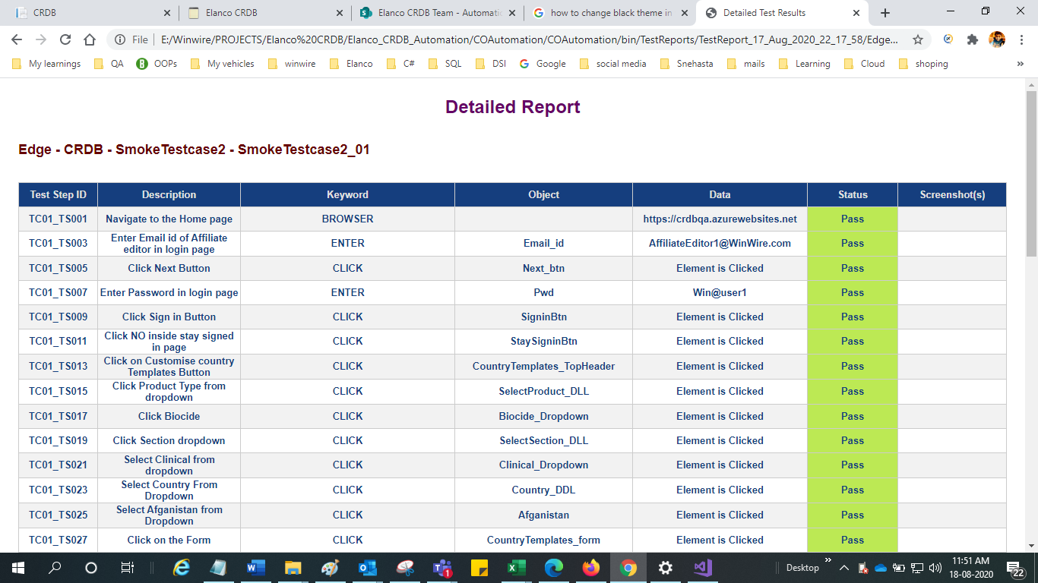

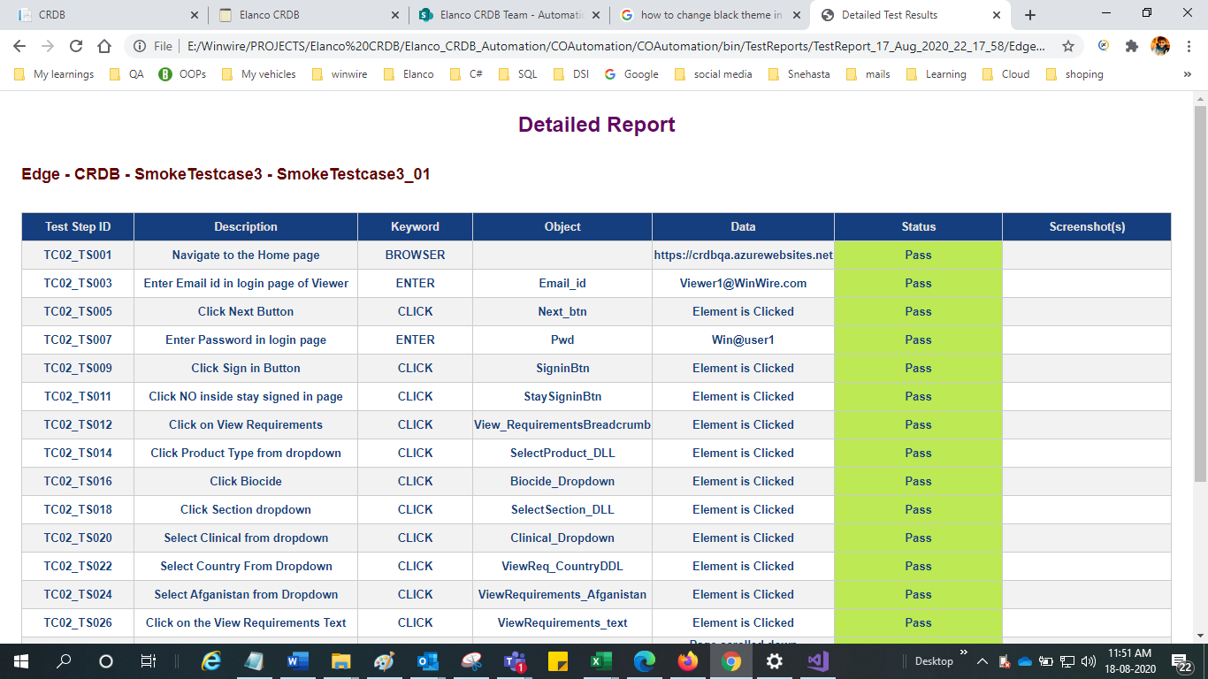

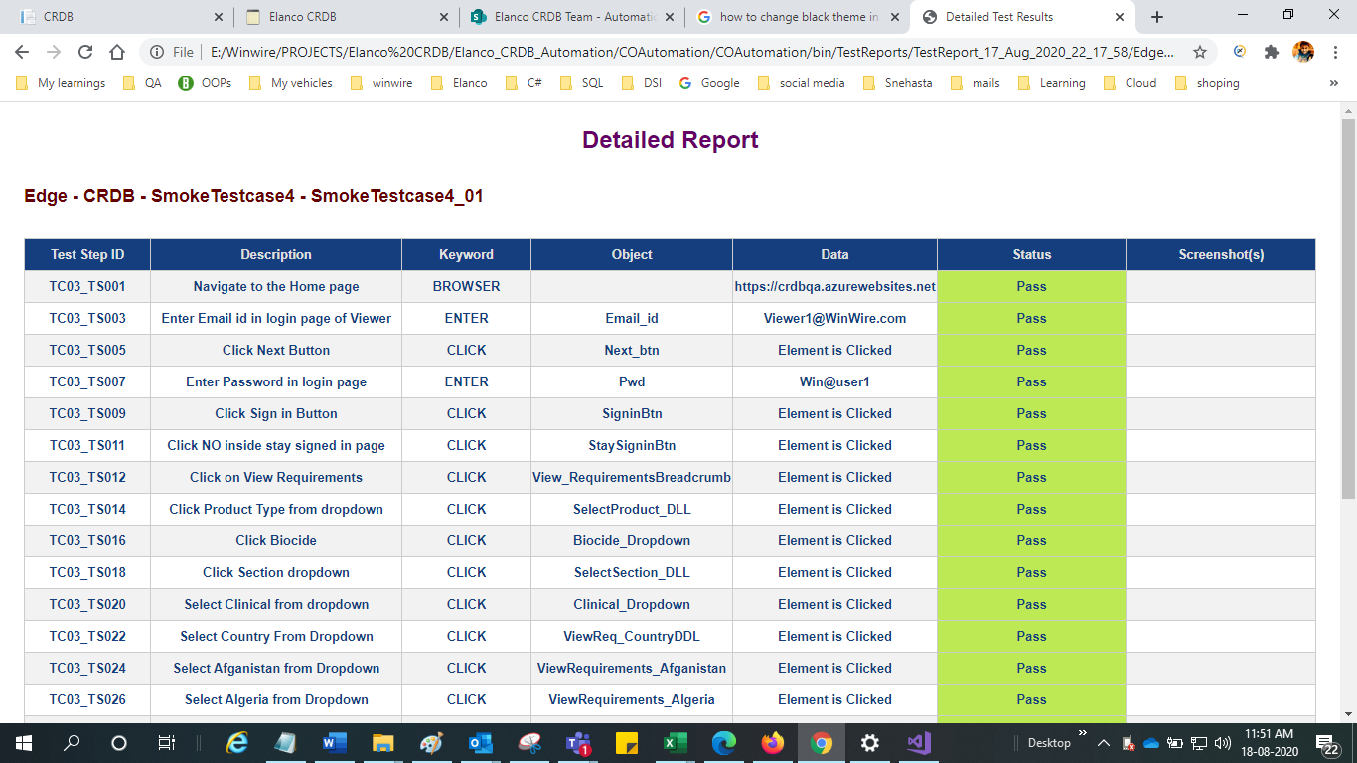

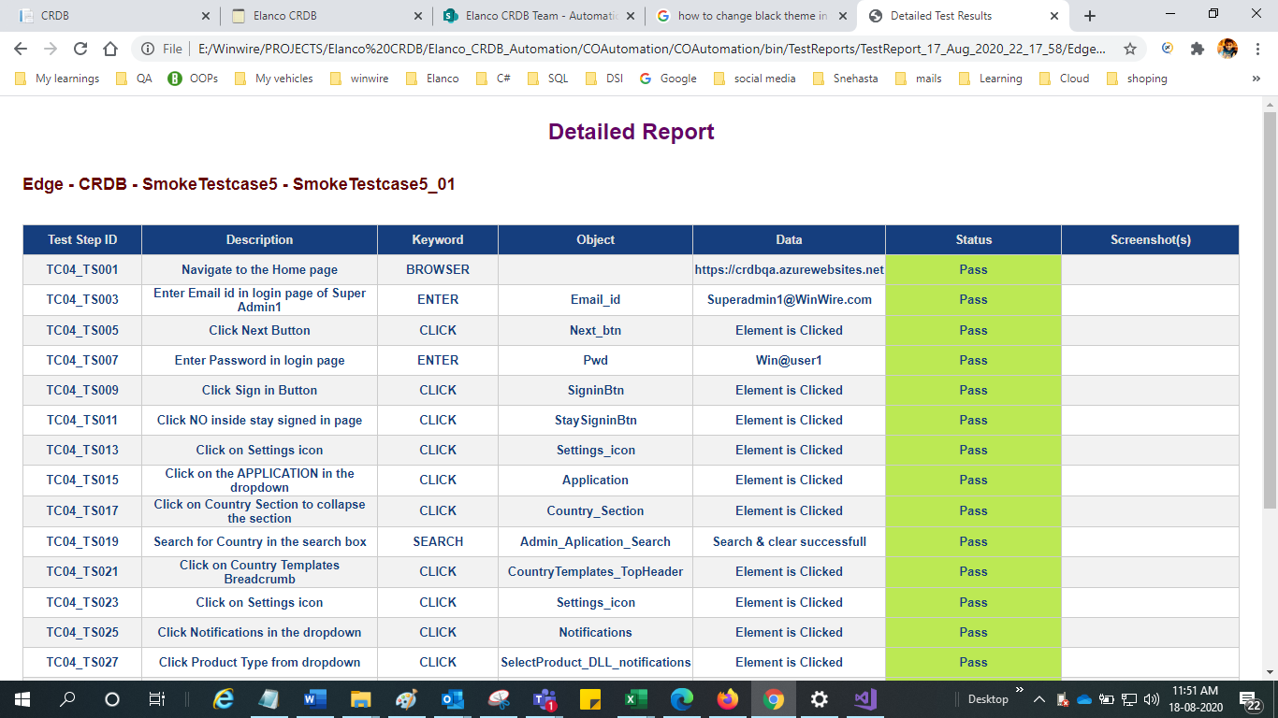

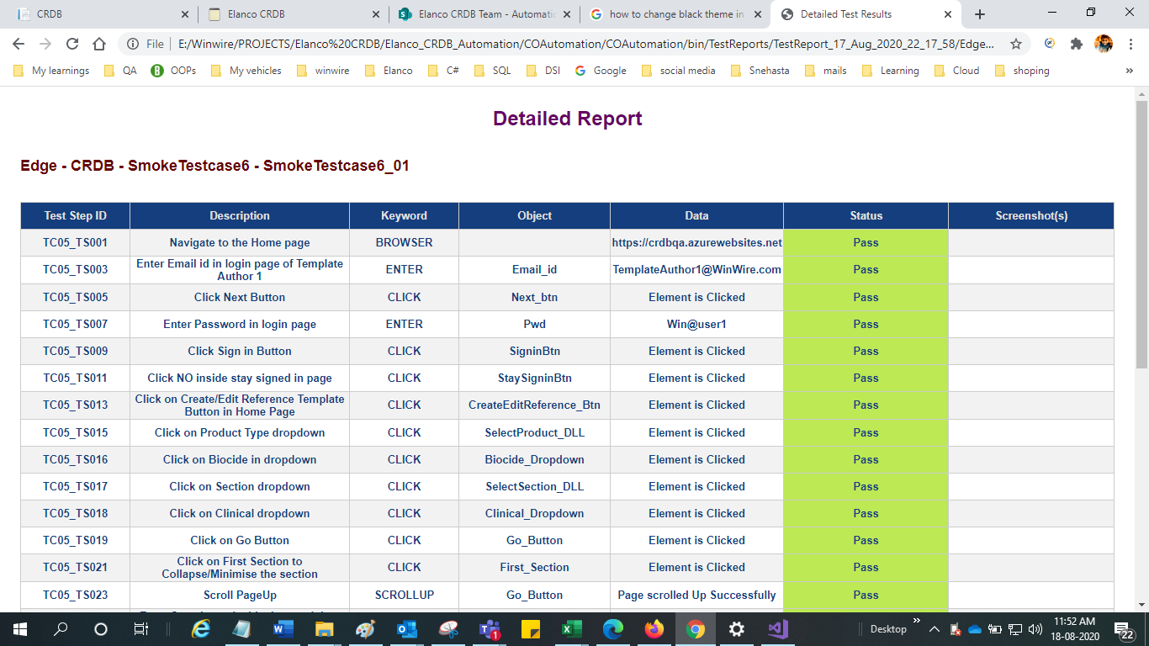

# Software’s Required

1.Visual Studio 2017 or greater

2.SQL Server management Studio

3.JVM

4.JDK/JRE

5.Chrome Brows Chrome Driver

6.Edge Browser / Microsoft Web driver

# Cleaning Test data.

1. After execution of test data, if user wants to clear test data, we need to run as SP to clear test data
2. Make sure Connection is set properly to the data base

WW - QA(DB)

-----------------------

Server=tcp:crdbqa.database.windows.net;Database=ElancoCRDB_qa;Trusted_Connection=False;user id=crdbstg ; password=Pass@Elanco1;

Elanco -Dev

----------------------

Server=tcp:elancocrdb.database.windows.net;Database=ElancoCRDB_dev;Trusted_Connection=False;user id=Elancocrdbadmin;password=Pass@Elanco1;

**Example: SP**

[dbo].[RevertSmoketestChanges] 'Biocide','Clinical','Afghanistan','2020-08-14 13:19:51.733','Template Author 1'

